**Test report**

**AdMe**

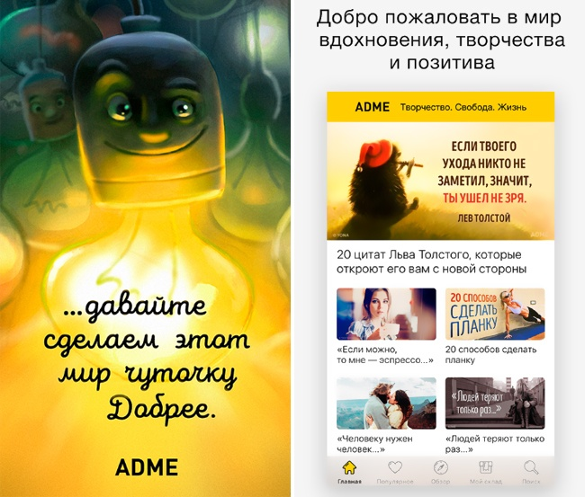

**Content:**

1. Goal
2. Risks
3. Test Environment
4. Bugs
5. Audience
6. Methods
7. Status

performers Team 13

# **1.0 Goal**

The purpose of this test report is to describe the results of testing the AdMe application, check the stability of operation, ease of use and correct operation of the application's functionality, and a brief description of the test results.

**2.0 Risks**

Associated with the inability of one or more team members to perform their work duties due to illness, lack of Internet, family reasons.

**3.0 Test Environment**

The AdMe application has been tested on devices:

iOS 12.1.4 iPhone 6s

Honor 8X Android 8.1.0

**4.0 Bugs**

During testing, 7 bugs were discovered:

|  |  |
| --- | --- |
| **Bug ID** | **BR2** |
| **Project** | **AdMe** |
| **Summary** | **The hint after entering a non-existent user is written in English** |
| **Component/s** | **UI** |
| **Steps to reproduce** | **1.Open ADME 2.Click on the icon in the upper right corner 3.Enter in the field for email: "qwe123@i.ua" 4.Enter in the field for password: "123" 5.Tap on the button "Войти"** |
| **Actual result** | **invalid credentials** |
| **Expected result** | **The hint is written in Russian "Неверные учетные данные"** |
| **Severity** | **4** |
| **Priority** | **4** |
| **Author** | **Kontvytskyi Dmytro** |
| **Enviroment** | **Honor 8X Android 8.1.0** |
| **iOS 12.1.4 iPhone 6s** |
|  |
| **Attachment** | [Image](https://drive.google.com/open?id=1nG_jHw_OgB2u94boOcCjtNW7oTdv-1bE) |

|  |  |
| --- | --- |
| **Bug ID** | **BR3** |
| **Project** | **AdMe** |
| **Summary** | **When creating an existing user, the hint is written in English.** |
| **Component/s** | **UI** |
| **Steps to reproduce** | **1.Open ADME 2.Click on the icon in the upper right corner 3.Tap on "НЕТ АККАУНТА? СОЗДАТЬ!" 3.Enter in the field for Name any valid name 4.Enter in the field for E-mail : "gioeffect@gmail.com" 5.Agree with user agreements 6.Tap on the icon in the upper right corner** |
| **Actual result** | **Email already exist** |
| **Expected result** | **The hint is written in Russian "Пользователь уже существует"** |
| **Severity** | **4** |
| **Priority** | **4** |
| **Author** | **Kontvytskyi Dmytro** |
| **Enviroment** | **Honor 8X Android 8.1.0** |
| **iOS 12.1.4 iPhone 6s** |
|  |
| **Attachment** | [Image](https://drive.google.com/open?id=18GsjucmW30aldUcCP3L9maUfOpoQCRBe) |
|  |  |
|  |  |
| **Bug ID** | **BR4** |
| **Project** | **AdMe** |
| **Summary** | **When you enter an invalid name during registration, the hint is written in English** |
| **Component/s** | **UI** |
| **Steps to reproduce** | **1.Open ADME 2.Click on the icon in the upper right corner 3.Tap on "НЕТ АККАУНТА? СОЗДАТЬ!" 3.Enter in the field for Name any invalid name 4.Enter in the field for E-mail any valid email 5.Agree with user agreements 6.Tap on the icon in the upper right corner** |
| **Actual result** | **Invalid name** |
| **Expected result** | **The hint is written in Russian "Некорректно введенное имя"** |
| **Severity** | **4** |
| **Priority** | **4** |
| **Author** | **Kontvytskyi Dmytro** |
| **Enviroment** | **Honor 8X Android 8.1.0** |
| **iOS 12.1.4 iPhone 6s** |
|  |
| **Attachment** | [Image](https://drive.google.com/open?id=10MZS5jKAdlXzJDItZtgIQJrlwtuHe2ZZ) |
|  |  |
|  |  |
| **Bug ID** | **BR5** |
| **Project** | **AdMe** |
| **Summary** | **User agreement tab is written in English** |
| **Component/s** | **UI** |
| **Steps to reproduce** | **1.Open ADME 2.Click on the icon in the upper right corner 3.Tap on "ПОЛИТИКА КОНФИДЕНЦИАЛЬНОСТИ"** |
| **Actual result** | **The whole page is written in English.** |
| **Expected result** | **The page is written in Russian** |
| **Severity** | **4** |
| **Priority** | **4** |
| **Author** | **Kontvytskyi Dmytro** |
| **Enviroment** | **Honor 8X Android 8.1.0** |
| **iOS 12.1.4 iPhone 6s** |
|  |
| **Attachment** | [Image](https://drive.google.com/open?id=1cPm3SsMgAaphn7BR7pNYSU419Zdh6zGL) |
|  |  |
|  |  |
|  |  |
| **Bug ID** | **BR6** |
| **Project** | **AdMe** |
| **Summary** | **iOS : doesn`t support English and Spanish** |
| **Component/s** | **Localization\ Globalization** |
| **Steps to reproduce** | **1.Change phone language to English\Spanish 2. Open AdMe App** |
| **Actual result** | **All pages are still in Russian** |
| **Expected result** | **Language is match with phone`s language or there is an option to change language at settings** |
| **Severity** | **2** |
| **Priority** | **2** |
| **Author** | **Zimoglyad Nastya** |
| **Enviroment** | **iOS 12.1.4 iPhone 6s** |
|  |
|  |
| **Attachment** | [Image](https://drive.google.com/open?id=1UZMeAwmJs_nMYeoNlVG1AGnI5Yz4CKAc) |
|  |  |
|  |  |
| **Bug ID** | **BR7** |
| **Project** | **AdMe** |
| **Summary** | **iOS : Gestures swipe to go back doesn`t work** |
| **Component/s** | **UX** |
| **Steps to reproduce** | **1.Open AdMe 2. Open first post at the news feed 3.Swipe from left side to turn back on a previous page** |
| **Actual result** | **No response to gesture** |
| **Expected result** | **Swipe helps go back on the previous page** |
| **Severity** | **4** |
| **Priority** | **4** |
| **Author** | **Zimoglyad Nastya** |
| **Enviroment** | **iOS 12.1.4 iPhone 6s** |
|  |
|  |
| **Attachment** |  |
|  |  |
|  |  |
| **Bug ID** | **BR8** |
| **Project** | **AdMe** |
| **Summary** | **No any notifications about page loading** |
| **Component/s** | **UI** |
| **Steps to reproduce** | **1.Open AdMe 2. Open first post at the news feed 3.Check if message "Loading" appears** |
| **Actual result** | **Blank page while loading** |
| **Expected result** | **An notification about page loading appears** |
| **Severity** | **4** |
| **Priority** | **4** |
| **Author** | **Zimoglyad Nastya** |
| **Enviroment** | **iOS 12.1.4 iPhone 6s** |
| **Honor 8X Android 8.1.0** |
|  |
| **Attachment** | [Image](https://drive.google.com/open?id=1vfDbZZuyfxkSigoq3d8pYUD7OpVqBHy4) |

**5.0 Audience**

The offer is intended for all people who can read (age 3+) interested in various articles.

**6.0 Methods**

In the process of testing manual testing was applied, functional, research, black box testing.

**7.0 Status**

Testing completed 25.03.2019 в 20:00.